Testimony of Sara Dorland for June 3, 2026 Over Order Premium Hearing
Since the implementation of the Federal Milk Marketing Order (FMMO) in May 2025, several changes have implications for Pennsylvania dairy producers and processors alike. Changes like the make allowance and Class I differential update have exacerbated the challenges already confronting the Class I sector in Pennsylvania. While the Class I differential maps were simplified and prices were raised, these changes led to more money moving from Pennsylvania’s Class I dairy producers to manufacturing in Pennsylvania, and all classes in New York, Ohio, Indiana, and Michigan. The Pennsylvania over-order premium remain vital as an antidote to address imbalances caused by the FMMO system that are detrimental to dairy producers and processors in Pennsylvania.
The Pennsylvania Milk Board website states that, “Pennsylvania's dairy industry is a vital contributor to the Commonwealth's agricultural economy.” It goes on to highlight the qualitative improvements the dairy industry brings to the state and its citizens, including open-space preservation, employment opportunities, and local dairy product supply, which is even more relevant given the national average fuel cost of $4.50/gallon. All of those attributes highlighted suggest that Pennsylvania’s dairy industry has an intrinsic value to the state, and the Milk Board should take steps to ensure its survival. While the focus of this discussion is on the merits of an over-order premium applicable to bottled milk and some cultured milk products, it should be understood that those products support a broader dairy portfolio, including its 27 cheese operations, 15 yogurt operations, one milk powder operation, eight butter operations, and 12 ice cream facilities, along with the dairy producers that supply those plants.

Pennsylvania Production Data
Over the past five years, Pennsylvania’s milk production declined to 9.74 billion pounds in 2025, a 5.3% decline from 2020 and 9.3% drop from 2010. From 2020 to 2025, Pennsylvania has lost 1,070 dairy producers and 40.6% of dairy farms since 2010. While declining farm numbers are a nationwide phenomenon, the drop in milk is not. US milk production increased 3.8% between 2020 and 2025. At the same time, the US Census Bureau reported that the state’s population increased by 63,856 people, suggesting that more of the state’s dairy is being imported from other states to meet regional per capita demand.
In 2024, Federal Order #1 (FO1) reported 7.83 billion pounds of Class I milk utilization. That same year, New York reported 3.09 billion pounds of fluid milk sales – accounting for 39.4% of FO1 Class I sales. The data implies that the remaining 46 plants, of which 15 are in Pennsylvania, produced the remaining 59.4% of Class I milk. It also indicates that Pennsylvania had the second-largest count of Class I processing assets in FO1, behind New York (16), and was a meaningful contributor to the blend price paid to producers.
Some western Pennsylvania counties are in Federal Order #33 (FO33). In 2024, FO33 reported sales of 6.87 billion pounds of fluid milk. In that order, Pennsylvania accounted for 930.5 million pounds of milk or 5.1% of the milk pooled on the order. That order contains several large processing facilities, including Blue Kingfisher, Fairlife, Tamarack Farms, Nestle, Mountaintop, and Superior Dairy, that will tend to dominate production. The data suggest that while Pennsylvania plants have a higher Class I differential, their volumes are smaller relative to those of larger processors in the region. Without exception, Pennsylvania Class I bottlers had the highest differentials in 2024, resulting in a proportionately higher contribution to the blend price.
Employing the Economic Impact of Elimination of Pennsylvania’s Minimum Milk Pricing System and based on the noted output trends, the following table provides estimates of Pennsylvania’s bottling activity in 2023 and 2024 using a linear trend analysis. Pennsylvania’s milk production continues to trend lower, as does fluid milk production, but it continues to maintain approximately 17% of total milk production. Class II sales are likely to exceed forecast, given the sizeable uptick in cultured production over the past two years.

Table 1. Forecast Fluid Milk Sales
 | 2017 | 2018 | 2019 | 2020 | 2021 | 2022 | 2023 | 2024
Pennsylvania Milk Production:
Supply to independent processors | 2,560 | 2,213 | 2,166 | 2,239 | 2,188 | 1,905 | 1,884 | 1,791
Cooperatives | 8,017 | 8,163 | 7,735 | 7,879 | 7,571 | 7,641 | 7,483 | 7,383
Producer-dealers | 65 | 63 | 64 | 76 | 76 | 74 | 74 | 73
Other | 251 | 217 | 142 | 86 | 280 | 328 | 269 | 284
USDA total for Pennsylvania | 10,893 | 10,656 | 10,107 | 10,280 | 10,115 | 9,948 | 9,859 | 9,737
Estimated PA fluid milk sales | 1,881 | 1,815 | 1,788 | 1,808 | 1,736 | 1,686 | 1,666 | 1,632
PA regulated Class I & II sales | 1,853 | 1,737 | 1,668 | 1,714 | 1,719 | 1,772 | 1,703 | 1,691
less PA tolling sales | 417 | 391 | 338 | 326 | 334 | 356 | 312 | 298
less other non-regulated sales | 10 | 5 | 9 | 8 | 8 | 9 | 8 | 9
Net PA milk subject to minimum pricing | 1,426 | 1,341 | 1,321 | 1,380 | 1,377 | 1,407 | 1,383 | 1,385
Est. volume not regulated by PMMB | 455 | 474 | 467 | 428 | 359 | 279 | 284 | 248
PA Class I sales relative to PA produce milk | 17.3% | 17.0% | 17.7% | 17.6% | 17.2% | 16.9% | 16.9% | 16.8%
Percent of PA fluid milk sales not subject to the minimum price | 24.2% | 26.1% | 26.1% | 23.7% | 20.7% | 16.5% | 17.0% | 15.2%
source: Economic Impact of Elimination of Pennsylvania's Minimum Pricing System; USDA milk production
Note: 2023 and 2024 are forecasts derived from a linear trend (Excel TREND function) fitted to 2017-2022 actuals.
Forecast cells shown in blue italic with light-grey fill.

Federal Order Changes
After May 2025, the USDA implemented several changes to the federal milk marketing order rules with some impact on Pennsylvania. First, the return to the higher-of pricing versus average-of plus $0.74/cwt pricing was used to establish the Class I skim value. Since June 2025, the impact has averaged $0.22/cwt, ranging from -$0.69/cwt to +$1.39/cwt.
The removal of barrel cheese from the National Dairy Product Sales Report (NDPSR) is inconclusive regarding its impact, as the CME spot barrel markets rarely trade, making an analysis of the impact highly speculative. It is noteworthy that since the June 2025 implementation, the CME Cheddar block market has traded nearly 6 cents below the NDPSR cheese price (June 2025 to April 2026 CME average $1.6045/lb; NDPSR $1.6636/lb), suggesting Cheddar barrels may have had some impact on the NDPSR cheese price. But the exact impact is difficult to ascertain, given exports and large cheese plant investments over the same span.
Increasing the solids nonfat content of Class I skim milk has enhanced the value since its implementation. Recognition of the addition of 0.3 pounds of protein and other solids (9.0 solids nonfat was increased to 9.3 pounds of solids nonfat per hundred pounds of milk), especially in periods of higher solids in nonfat markets. This was a delayed implementation that occurred in December 2025.
The allowance had the most straightforward impact on dairy producers' milk checks, as it resulted in a net reduction. If the higher make allowance resulted in fewer milk check adjustments or “reblends,” the impact per dairy producer could be less than the absolute make allowance change, as there may have been offsets.
Changes to the Class I differential have the greatest systemwide impact and surprised the industry when the first settlement month arrived.

Location Differentials
While industry and testimony during the hearing process focused on the need to increase transportation reimbursement for dairy producers serving the Class I market, there was little discussion of the monumental changes to the overall map and their impact on processors and producers. USDA engaged experts to modernize the differential map to reflect milk supply versus plant locations and the cost of serving the market, but the changes went beyond reimbursing for the costs of serving Class I plants and ended up taking money from the Class I sector to fund the manufacturing sector. My analysis of PAMD member plants shows that many of their farmers are not receiving the full reimbursement – i.e., Pennsylvania’s Class I producers in some areas are receiving less of the Class I differential than before FMMO change.
The location differential discussions focused on the cost of service Class I facilities and the need to raise those costs. The map attempts to do this by recognizing population centers with fewer cows at higher rates than surplus counties with more milk than consumption, meaning a bottling plant in Philadelphia could cost more to service than one in Lancaster. That was reflected in the Philadelphia location differential moving to $4.60 from $3.05/cwt (+31%) and Lancaster, $4.30 from $2.90 (48%). So that means a Class I distribution plant in Philadelphia, PA, would pay $4.60/cwt location adjustment, June 2025 forward.
However, there is a secondary application of the location differential: the zone in which producers are located will also affect payments and obligations. Unlike processor assessments, which apply only to distribution plants, producer location differentials apply to all pooled milk.
To demonstrate, assume a bottling plant in Philadelphia buys milk from Lancaster County. Example 1 shows the charges to the Class I plant and payment obligation to the dairy producer based on current location differentials and February 2026 prices. Example 2 looks at February 2026 milk prices, but with the previous location differentials (those prior to June 2025).

Example 1. Processor Obligation for one-hundred pounds of Class I milk only
February 2026 | Pounds | Rate | Extended
Class I Skim | 96.5 | $9.99 /cwt | $9.64
Class I Butterfat | 3.5 | $1.4446/lb | $5.05
Class I differential @ location |  | $4.60 | $4.60
Total Producer Milk | 100 |  | $19.29
Producer lbs x Producer Differential | 100 | $2.37/cwt | $2.37
Butterfat x Butterfat Price | 3.5 | $1.7794 | $6.23
Protein x Protein Price | 3.3 | $1.9373 | $6.39
Other Solids x Other Solids Price | 6.0 | $0.4391 | $2.63
Location Adjustment | 100 | -$0.80 | -$0.80
Credits to Handler |  |  | $16.82
Payment to the settlement fund |  |  | $2.47

Example 2. Based on Location Differentials before June 2025
February 2026 | Pounds | Rate | Extended
Class I Skim | 96.5 | $9.99 /cwt | $9.64
Class I Butterfat | 3.5 | $1.4446/lb | $5.05
Class I differential @ location |  | $3.05 | $3.05
Total Producer Milk | 100 |  | $17.74
Producer lbs x Producer Differential | 100 | $2.37/cwt | $2.37
Butterfat x Butterfat Price | 3.5 | $1.7794 | $6.23
Protein x Protein Price | 3.3 | $1.9373 | $6.39
Other Solids x Other Solids Price | 6.0 | $0.4391 | $2.63
Location Adjustment | 100 | -$0.35 | -$0.35
Paid by Handler |  |  | $17.27
Payment to the settlement fund |  |  | $0.47

For producers selling milk to Class I processors, the new differentials reduced their reimbursement by $0.45/cwt in this example. While the Class I processor pays $1.55/cwt more, the market absorbs the difference. Given the amount of milk moving to manufacturing, most of the Class I reimbursement moved there.
There were comments that the map did not accurately reflect commercial movement between farms and processors, and the implications were not well understood. While there is a stated “reimbursement” for the cost to service the Class I market, the change meant that Class I producers are now giving away a bigger portion of the Class I differential when they receive adjustments outside of their processor’s zone (which is commonplace across PAMD member plants) outside of the same zone and that amount is distributed to manufacturing in Pennsylvania and worse for Pennsylvania’s Class I producers that money is subsidizing pay outs to farms outside of Pennsylvania.
While a dairy producer may deliver to a Class I bottling plant, if they are in a lower location zone, they would be reimbursed as if the delivery were to their zone, not to the actual plant location. That means Pennsylvania’s Class I plants, which producers expect to pay favorable prices, will have the same amount of money to distribute to their farmers as manufacturing plants without the Over Order Premium. This creates the potential for serious competitive issues in terms of retaining a milk supply for Class I plants. Without having a revenue source to incentivize their farmers to deliver.

Image 1. Northeast Location Differentials
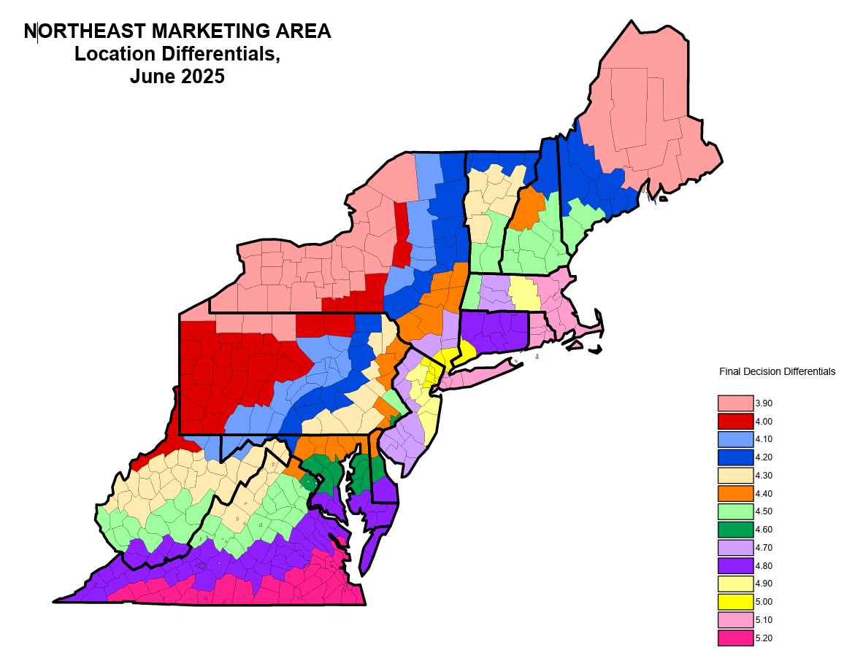

/https://marketready.uky.edu/sites/default/files/2024-07/a-survey-of-pennsylvania-value-added.pdf
https://agriculture.ny.gov/system/files/documents/2025/08/2024dairystatisticsannualsummary.pdf, Page 8
https://www.fmmone.com/Plant_List/Pool-2024.pdf
https://www.pa.gov/content/dam/copapwp-pagov/en/pmb/documents/board-initiatives/Economic%20Impact%20of%20Elimination%20of%20Pennsylvania%27s%20Minimum%20Milk%20Pricing%20System%20November%202023.pdf
https://www.fmmone.com/Maps/NE-Diff-Zone-Map-Eff-6-1-25.pdf

