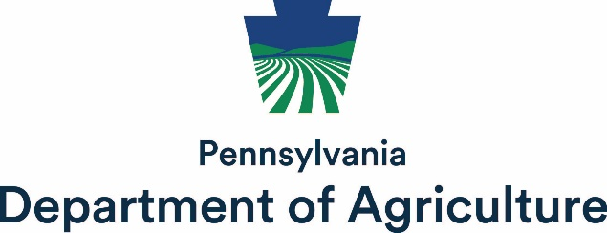

Farm Safety & Occupational Health Board
March 18, 2026
10 AM – 12 PM

In Person: PDA, 2301 N Cameron Street, Harrisburg, PA 17110
Virtual: Link to Join Meeting; (267) 332-8737, Meeting ID: 814 535 78#

Agenda

New Members
- Rita McMullen – PDM Insurance Agency (Insurer of Farmers)
- David Eberly – New Holland Farm (Ag Equipment & Machine Manufacturer/Dealer)
- Vacancies
  - Leader of an Agricultural or Rural Youth Organization

Approval of Minutes from October 16, 2025

Metal Health (Sara Gligora and Florance Becot)
- Priority of the legislature.
- Increase awareness of available resources.
- PSU’s Suicide Prevention Curriculum.
- Farmer to Farmer Interactions/Testimonials
- Any sectors of industry that need focus?

Child Safety (Jameekia Barnett)
- Improving child safety practices.
- Practices that could lead to child abuse/neglect cases with Department of Human Services.
  - Where to draw the line between cultural norms and child neglect/abuse.
  - Many different jurisdictions with many different opinions.

Gaps in Insurance and Safety (Frank Schneider)
- Identify gaps and how we can fix them.
- Workgroup?

Board Member Roundtable

Public Comment Period

Adjourn

Next Meeting: July 15, 2026 at 10:00 am (in-person and virtual)

