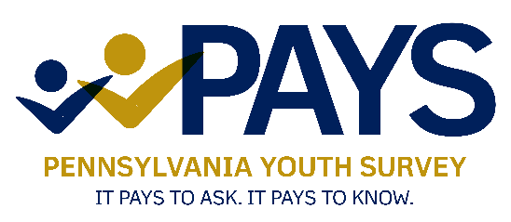

Pennsylvania Youth Survey

Passive Parental/Caregiver Permission Letter

Dear Parent or Guardian:

Our school is taking part in the 2025 Pennsylvania Youth Survey (PAYS) sponsored by the Pennsylvania Commission on Crime and Delinquency, the Pennsylvania Department of Education, and the Pennsylvania Department of Drug and Alcohol Programs. The survey will ask questions about the behaviors of students in the 6th, 8th, 10th, and 12th grades, including questions about school climate, mental health, violence, bullying, and substance use.

The information we receive will assist us and our community partners in working to promote mental health and prevent substance use and other problem behaviors. We want to ensure that all parents and caregivers are notified the survey is being conducted as well as provide you with as much information about the survey as possible. As a parent or caregiver, you have the right to prohibit your child’s participation. The following facts about the survey will help you make an informed decision:

* Participation in this survey is completely voluntary. Students will be instructed by their proctor that they can skip any questions they do not understand or choose not to answer. If they have any questions or concerns after taking this survey, they are instructed to talk with their school counselor or a trusted adult.
* The survey is designed to protect each student’s privacy; it is anonymous and confidential. Students will not put their names on the survey, and no student will ever have their individual responses reported.
* The survey is well tested, having been administered to over 2 million Pennsylvania students since the 1990’s. The information collected has proved invaluable to prevention planners in selecting programming to promote healthy youth development.

You can request a list of the survey questions by visiting this link: <https://epis.psu.edu/PAYS/question>. For more information about the survey, including a list of Frequently Asked Questions, please visit [www.pays.pa.gov](https://www.pays.pa.gov).

The survey will be administered during the school day later this fall and will take one class period to complete. If you do not want your child to participate, please submit your request to [INSERT NAME] in writing.

Thank you for your help in our efforts to keep our schools drug free and safe for learning. If you have any questions, please contact [INSERT NAME] at [INSERT PHONE NUMBER].