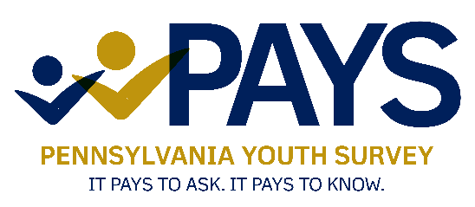

Pennsylvania Youth Survey

**Passive Parental/Caregiver Request Tracking Form**

District: ______________________________________________________

School: ______________________________________________________

School Contact: ______________________________________________________

Survey Date: ______________________________________________________

This form tracks parent or caregiver refusal for Pennsylvania Youth Survey participation. When preparing the survey packets for proctors, use this form to identify students who DO NOT have parental or caregiver consent to take the survey. Please notify proctors which students are not permitted to take the survey. **Please provide these students' names to proctors before the survey administration.**

| Parent or Caregiver Name | Student Name | Date school received notification in writing that the student is NOT permitted to take the survey. | Proctor to be notified of written Parental Request and proctor email | Date on which the proctor was notified |
| --- | --- | --- | --- | --- |
| SAMPLE: Mrs. Ann Jones | Billy Jones | 9/5/2025 | Mrs. Smith  mrs.smith@sch.edu | 10/10/2025 |
|  |  |  |  |  |
|  |  |  |  |  |
|  |  |  |  |  |
|  |  |  |  |  |
|  |  |  |  |  |
|  |  |  |  |  |
|  |  |  |  |  |
|  |  |  |  |  |
|  |  |  |  |  |
|  |  |  |  |  |
|  |  |  |  |  |