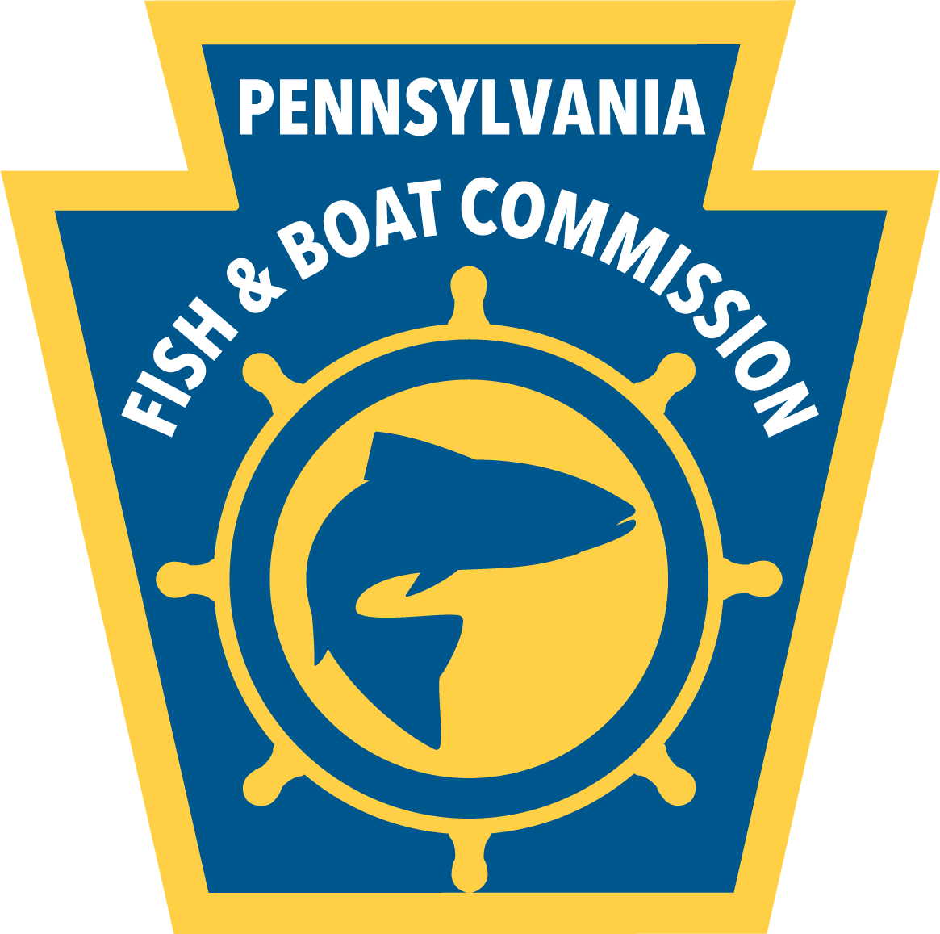
Valley Creek Trustee Council
Grant Application Package

This package guides potential applicants to the Valley Creek Trustee Council’s Restoration Fund for Valley Creek restoration projects. Part A describes the program being implemented under the Restoration Fund, including qualifications for grants. Part B contains the application checklist, application data sheets, and any accompanying instructions for completing the application. Part C describes the evaluation system for grant applications.

PART A: Restoration Fund Grant Program Information and Instructions

Before an applicant completes the application form (Part B), it is important to read Part A to ensure that (1) the project is of the type that may be granted by the Restoration Fund, and (2) the applicant understands how the Restoration Fund will be administered. This Part provides information regarding the following issues:
- Purpose of the Restoration Fund
- Projects Eligible for Funding
- Pre-application Contacts
- Dates and Locations for Submission of Applications
- Eligible Applicants
- Process Used by VCTC to Evaluate Applications
- Terms, Amount, and Conditions of Grants

Purpose of Restoration Fund

In the mid-1980’s the Valley Creek watershed was contaminated by PCBs (polychlorinated biphenyls) from the Paoli Rail Yard Site. The contamination caused the Pennsylvania Fish and Boat Commission (PFBC) to stop stocking trout in Valley Creek, establish a catch-and-release only requirement, and issue a health advisory regarding the consumption of trout. As a result, angling in Valley Creek suffered significantly. In a legal settlement, rail companies operating facilities at the Paoli Rail Yard Site paid monies to the U.S. Department of Interior (DOI) and Pennsylvania Fish and Boat Commission (PFBC) to compensate for the lost angling and other recreational uses of Valley Creek. These monies were placed into the Restoration Fund which is administered by the Valley Creek Trustee Council (VCTC) for the purpose of planning and conducting appropriate restoration of natural resources within the Valley Creek watershed. The VCTC consists of representatives of both the Valley Forge National Historical Park (VFNHP), acting on behalf of the DOI, and the Pennsylvania Fish and Boat Commission.

The VCTC’s detailed program is contained in an August 2004 document entitled Valley Creek Restoration Plan. The Restoration Plan presents restoration strategies and projects that can be implemented to enhance natural resources within the Valley Creek watershed and improve the Valley Creek fishery. This document was developed by the VCTC under National Environ -mental Policy Act guidelines and requirements. Copies of this plan and a downloadable copy of the grant application package and form are available on the following website:
https://www.pa.gov/services/fishandboat/valley-creek-watershed-grant.html
The VCTC encourages the community’s involvement in this program by applying to implement the types of projects envisioned under the Restoration Plan.

Projects Eligible for Funding

The VCTC has identified five broad categories of projects that are likely to compensate for past lost uses of the Valley Creek watershed (e.g. angling) through improvements in habitat, water quality, and flow regime and by improving public access to the stream. Projects eligible for funding must fall into one of the following categories:

- Stormwater Management
- Stream Channel Stabilization
- Establishment of Greenways
- Increased Public Access to streams
- Brook Trout Restoration in Crabby Creek, Tributary to Little Valley Creek

Prioritization of projects by location in the watershed was addressed by VCTC in the Valley Creek Restoration Plan. The VCTC favors stormwater projects that are in first order streams. The VCTC has determined that stream channel stabilization projects should be implemented after upland stormwater projects have been considered and/or implemented. Applicants should check the Valley Creek Restoration Plan posted on the PFBC website to determine the location(s) of various projects that have been recommended for funding.

The VCTC will not approve projects which solely involve research, education, or outreach associated with the water resources of the Valley Creek Watershed. Education or outreach for projects funded by the Trustee Council is encouraged, and in some cases is fundable; however, such work should be ancillary to the primary watershed restoration objectives indicative of the five aforementioned project categories that are further described below.

Stormwater Management. Managing stormwater helps reduce stormwater runoff that erodes stream banks and causes the greatest amount of sediment buildup in Valley Creek Watershed. By permitting greater amounts of precipitation to evaporate or enter the soil and supplement the base flow to Valley Creek, the volume and velocity of storm flow in Valley Creek would diminish and result in a corresponding reduction in both eroded streambanks and flooding. There are three project categories for managing stormwater: retrofits of detention basins, infiltrating on lands suitable for infiltration (LSI), and infiltration using low-impact technology projects on small parcels of developed land (LID).

Stream Channel Stabilization. Poor fish cover, bank instability, lack of riparian vegetation, and excessive sedimentation are four issues that would be addressed by stream channel stabilization projects. Two types of stream channel stabilization are generally possible: stream improvements and streambank stabilization. Stream improvements consist of creating pools to provide deeper cool spots for fish when water warms up during summer, providing cover for fish to escape natural and human predation, and narrowing stream channels to keep waters deeper and cooler and to provide sediment transport that removes excess sediment bars and deposition. Stream stabilization reduces erosion and sediment generation by reestablishing a balanced sediment transport process for the stream.

Greenways Methods. Project categories to achieve greenways include:

land preservation from development or from activities that would cause increased runoff or pollution in the stream.

conservation easements on private lands – includes the placement of easements on lands in order to prevent the use of impervious surfaces on that land

stream buffers in riparian corridors that have a variable width depending on type of growth

Increased Public Access. This category would make it easier for anglers and other visitors to access or view the streams. Methods include:

reducing the amount of posted (no trespassing) land unavailable to anglers

creating more fishing points and increase parking availability (without increasing runoff) for stream visitors and anglers

creating trails that would enhance access to streams

Fish Restoration on Crabby Creek. Crabby Creek (Unnamed tributary to Little Valley Creek in PFBC records) had a wild brook trout population as late as 1995. On October 2, 2002, surveys of two 150 meter stretches of Valley Creek produced no brook trout. The PFBC believes the brook trout population has been extirpated primarily due to scour. Hurricane Floyd in September 1999 may have had a significant impact on the brook trout population. The PFBC recommends re-establishing brook trout upstream from S.R. 252 as an appropriate restoration goal.

Preapplication Contacts
Applicants may contact Jeff Schmid, PFBC staff person and grant program administrator, if they have questions about the program or the application process. He can be reached at 814-359-5242 or contacted at jschmid@pa.gov or Pennsylvania Fish & Boat Commission, 595 East Rolling Ridge Drive, Bellefonte, PA 16823.

Date and Location for Submission of Applications

Applications will be accepted at any time; however, incomplete applications will not be considered. If only paper copies are being submitted, then four copies of the completed application package must be submitted to Mr. Schmid at the address shown above. An electronic copy of an application using MS Word software is acceptable and preferred over hard copies and may be delivered via e-mail attachment or snail mail on a CD or thumb-drive.

Eligible Applicants

Any person or organization that meets the following criteria may apply for grants. Eligible applicants include Chester and Montgomery counties, municipalities, municipal authorities, county conservation districts, councils of governments, other local government agencies, and educational institutions. In addition, nonprofit watershed organizations, sportsmen’s groups, conservancies, and organizations involved in water resource restoration and protection are eligible. Organizations claiming to be nonprofit may be asked to provide substantiating documentation that they have obtained 501 (c) (3) tax exempt status from the Internal Revenue Service.

Although the eligible agency or organization does not have to be located in the Valley Creek watershed, the project must be implemented in the watershed. Funds from this grant may not be used for the design and installation of Best Management Practices or other environmental impact mitigation measures that are required by law, regulation, or permit.

For-profit companies, individuals, or organizations are ineligible to apply for grants; however, such providers of goods and services may be contracted by eligible grantees or directly by the Valley Creek Trustee Council.

Process Used by VCTC to Evaluate Applications

Applications will first be reviewed for completeness. Although the VCTC will attempt to obtain missing information from the applicant, it is the applicant’s responsibility (and not that of VCTC) to ensure that application packages are complete. Incomplete applications will not be considered in the evaluation process. The VCTC may request supplemental information and/or a site visit if it determines that such information is necessary to assist them in evaluating an application. Applications will be scored using the system described below in Part C.

A potential applicant may submit a 1-2 page letter of inquiry to the grant program administrator prior to submitting a full application. This letter should describe the project and provide an estimated cost and outcome. The resource coordinator will then discuss with the potential applicant whether the described project qualifies.

Terms, Amount, Fund Match, and Conditions of Grants

Although there is no specific limit regarding the maximum amount of funding awarded for selected projects, the VCTC’s decisions regarding particular applications may be limited by the amounts available in the Restoration Fund and the need to accomplish certain objectives. The VCTC may award less or more funding than requested within a grant application. NOTE that the minimum funding request amount of $30,000 is required for grant application consideration.

Matching funds of at least 25 percent of the estimated total project cost are required. This requirement became effective on March 20, 2014. While evaluating grant applications, greater match amounts will accrue more points when the application is scored.

All applicants will be required to obtain necessary environmental and building permits from appropriate local, state, and federal agencies. Where necessary, applicants must also conduct appropriate archeological and historical surveys and all surveys for wetlands and endangered and threatened species. As required, additional terms and conditions of grants will be developed for projects on an individual basis. Costs associated with obtaining required permits and conducting necessary surveys may be reimbursed to applicants, if requested in the application and approved within the Cooperative Grant Agreement prepared following a grant award, or such costs may be considered a matching or in-kind contribution.

The VCTC will generally withhold up to ten percent (10%) of the total approved amount of funding until all terms and conditions of the grant have been successfully accomplished and the VCTC has determined the project is complete.

PART B. Grant Application Forms and Checklist

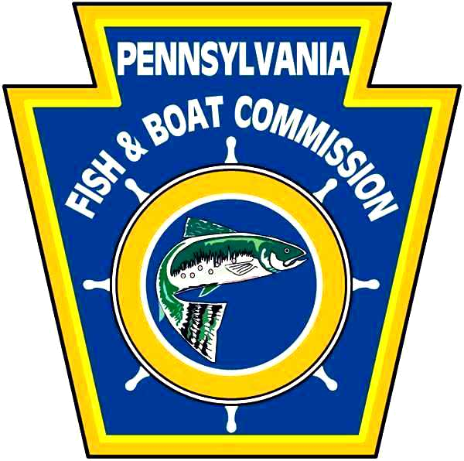

A complete application includes all information indicated in the checklist below, and the applicant’s completed checklist. This checklist if for use by both the grant applicant and the reviewers.

Application and Attachments Checklist
√ |  | Description
 | 1. | Applicant and project information (Sheet 1)
 | 2. | Project Description (Sheet 2)
 | 3. | Project Questions (Sheets 3, 4 and 5); If needed, provide response to project question #14 as an attachment.
 | 4. | Project Budget and Matching Amounts (sheet 6)
 | 5. | If needed, attached related project descriptions from project question #14.

Please Provide the Following as Attachments: (Please label attachments clearly)
 | 6. | Letters of Commitment from each affected landowner with direct impacts on their property as a result of the proposed project.
 | 7. | Project Area Map
 | 8. | Project Design Drawings or Sketches
 | 9. | If a Nonprofit Organization, Legal Proof of Tax Status
 | 10. | Letters of Support from Affected Entities or Partners
 | 11. | Current budget or most recent financial report

Note: VCTC may request additional information regarding the applicant or project.

APPLICANT INFORMATION (if completing on behalf of a corporation, association or club, that entity is the applicant)
Applicant name:  Address:  E-mail: |  |  |  | Applicant telephone: |  |  | Applicant Fax:
Organization name:  Address:  E-mail: |  |  |  | Tax code status:  Federal ID Number:
Project contact person name (if different from applicant):  Address:  E-mail: |  |  |  | Contact telephone: |  |  |  | Contact fax:
The applicant certifies the truth of the statements contained in this application package. The person signing must be authorized by the applicant to sign on its behalf and the applicant must attach satisfactory confirmatory documentation.
Applicant signature: Date:

Please print name here:

PROJECT INFORMATION
Project Title: |  |  |  |  |  | Submittal date:

Project type (please check applicable category)
⁫ Stormwater management ⁫ Stream Channel Stabilization ⁫ Greenways
⁫ Increased public access ⁫ Fish restoration

Check one:
⁫ Initial Submission ⁫ Resubmission

If resubmission, date application was originally submitted:

Proposed project start date: Project duration:

Amount Requested: |  | Matching Amount: |  |  | Total Project Cost:
VCTC use only – Do not complete this section
Date received: |  |  | Complete: ⁫ Incomplete: ⁫
Additional information:
 | PROJECT DESCRIPTION
 | Provide a description of the project, including (1) a description of baseline conditions, (2) the objectives for the project, (3) a list of tasks that will be undertaken, (4) measureable results and/or desired outcomes, (5) project deliverables (draft and final reports and other project documentation), (6) project schedule including deliverable due dates, and (7) any sketches or conceptual drawings relating to the design of the project.

PROJECT QUESTIONS (to be answered as part of the application)
1. | Provide a paragraph describing your organization’s purpose and a paragraph describing why you are interested in conducting a restoration project in the Valley Creek watershed.
2. | (a) Could this project be undertaken by other watershed programs if VCTC did not fund this project? If yes, please explain. (b) Is this project required for regulatory reasons? If yes, please explain.
3. | Briefly describe what problem(s) in Valley Creek Watershed this project will address?
4. | (a) Are any permits required for the project? If yes, please explain. (b) Are any environmental surveys required for the project? If yes, please explain. (c) What is the schedule for obtaining appropriate permits and/or surveys?
5. | (a) Can this type of project be replicated in the watershed? (Yes or no)  (b) Will it catalyze others to pursue similar projects? If yes, please explain.
6. | Will this project provide any educational benefits for the community? If yes, please explain the nature of the benefits and identify which parts of the community/population will be the recipients of the educational benefits?
7. | (a) Will this project require any maintenance after completion? If yes, please explain the type of maintenance required, how it will be accomplished, and how much it is expected to cost.
8. | What short or long-term monitoring activities will be implemented to evaluate project success? Please provide the parameters being measured, frequency of sampling, duration of monitoring and describe the relationship between monitoring activities and project success.
9. | Please provide a quantitative description of permanent improvements to recreational use (e.g. number of people with increased access to stream), in-stream habitat (e.g. number of spawning areas, number of linear feet within stream with improved cover), or other ecological improvements (e.g. gallons of stormwater infiltrated per year, number of linear feet of buffer, length of streambank stabilization) expected to result from project implementation.
10. | Does this project relate to other projects in the watershed or in the vicinity of the project? If yes, please describe the nature of the relationship.
11. | Provide a map showing where the project will occur and the location of any other related projects in the immediate area. ATTACH MAP TO APPLICATION (if latitude/longitude available, please include)
12. |  | Identify and describe any partners involved in project development and/or implementation and the roles played by each. Include in your description any matching funds or in-kind contributions.
13. |  | Provide one paragraph descriptions for each key person who will be working on this project, indicating name, affiliation, role they will play, accomplishments and qualifications.
14. | Provide descriptions of up to five projects that the applicant organization has been involved in that demonstrate its ability to successfully design and implement projects similar to the one proposed for funding. If possible, describe projects in which the same ‘key persons’ identified in question 13 above participated. Descriptions should be no more than one paragraph for each related project. Describe below or attach separate sheets.

PROJECT BUDGET AND MATCHING AMOUNTS
Category | Description & Unit Cost & Quantity of Units | Grant Funds Requested | Match/Contributions and Source  (Cash and/or In-Kind)
Salary and Benefits
Travel
Equipment/
Supplies
(List each item;
Attach additional sheets if necessary)
Construction
Contractual
Acquisition
Administrative*
Other
(Itemize)
TOTALS

*May not exceed 15% of total grant request

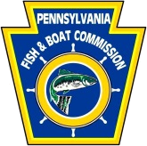
PART C. Evaluation System for Restoration Projects

The following system will be employed by the Trustee Council to evaluate specific projects for adoption into the Plan. Projects will first be screened to determine whether they qualify for further evaluation. Projects that do not meet the basic screening criteria will be returned to the applicant. Next, the project has to satisfy four threshold criteria. Projects that do not satisfy any one of the four criteria listed below will be returned to the applicant. Projects that meet both the screening and threshold criteria will be scored and ranked.
Add all points per project and divide into the total project cost. Projects that include greater amounts of matching funds and/or in-kind services will be scored higher.
At the end of the process, the rankings will be divided into three categories of preference; high, moderate, low. This reflects the overall uncertainties in the process and the imprecision of the scoring system below.
Category | Evaluation Questions for Restoration Projects | Score
Screening | Is the application complete? | Yes No
Screening | Does the proposed project fall into one of the five pre-designated eligible categories (i.e., greenways, stream corridor improvements, stormwater management, Crabby Creek brook trout restoration, increased public access to streams)? | Yes No
Screening | Is the information provided sufficiently detailed to understand the problem, action(s), and outcomes? | Yes No
Screening | Would this project be implemented without the Restoration Fund? | Yes No
Screening | Is the project an activity that is the responsibility of a regulatory agency or the regulated community? (e.g., a party that is under legal obligation to reduce pollution.) | Yes No
Screening | Does the application include a notarized document signed by each affected property owner (public or private) that authorizes the grantee property access and completion of the proposed work on the property? | Yes No
Threshold Criteria | Technical feasibility. Is the project technically sound taking into account the level of uncertainty or risk and experience in implementing the project? | Yes No
Threshold Criteria | Is the project consistent with restoring lost uses of Valley Creek's resources? | Yes No
Threshold Criteria | Does the proposed project comply with all applicable laws? | Yes No
Threshold Criteria | Does the proposed project pose a threat to the health and safety of the public? | Yes No
Scoring | Does the applicant provide more than 25% Match? If so, how much match is provided? | >89% 66-89% 31-65% 26-30% 25%  7 5 3 1 0
Scoring | Do the project cost estimates in the proposed budget seem reasonable and realistic? | Yes No  3 0
Scoring | Will successful completion of this project encourage other landowners to follow suit? | 4 3 2 1 0
Scoring | Positive educational benefit to the community. | 2 1 0
Scoring | Is there an Operation, Maintenance, & Repair Plan that identifies the responsible party & an inspection and repair time frame? | Yes No  3 0
Scoring | Cost & ease of maintenance required over time. | 4 2 0
Scoring | Ability of individual or organization to monitor project results. | 2 1 0
Scoring | What is the applicant’s record of cooperation and performance for prior VCTC grants? | 4 2 0
Scoring | What is the likelihood of overall project success? | 3 2 1 0
Scoring | Potential for successful restoration, replacement, and/or acquisition of natural resources within the Valley Creek watershed?
Scoring | A. Likelihood of permanent increase in recreational use (fishing, hiking, other recreation) including existing user increases in satisfaction. | 5 4 3 2 1 0
Scoring | B. Likelihood of permanent out-of-stream ecological improvement of  the watershed (reduced stormwater runoff, increased infiltration,  riparian enhancement for aquatic life [e.g., wetlands, forested  buffers]). | 5 4 3 2 1 0
Scoring | C. Likelihood of permanent instream habitat improvement (improved  spawning areas, improved cover, reduced sediment, improved  insect population) | 5 4 3 2 1 0
Total Score:

