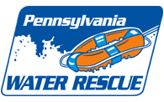

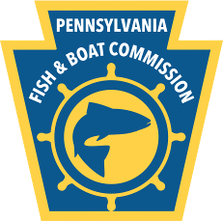
To: Water Rescue and Emergency Response Instructor Candidates
From: Chris A. Calhoun – Course Coordinator
Date: November 7, 2025
Re: Course Information and Registration Form
Dates, Times, and Location of Training:
June 2-4, 2026
- Tuesday 6/2 – Classroom - Start time 9:00 am – Butler, PA
- Wednesday 6/3 – Classroom and pool session
- Thursday 6/4 – Classroom and outdoor practical

Course Focus: The three days of training will teach you how to instruct the standardized water rescue curriculum of the Pennsylvania Fish and Boat Commission. The course will provide an overview of each curriculum and instruct participants in teaching techniques and tools used to deliver the program in the classroom, pool and outdoor practical sites. Instructor trainers will evaluate your technical water rescue skills and focus on improving these skills to instructor level proficiency.

Students will understand the importance of preplanning and the significant logistical demands required for the delivering these courses. They will learn how to prepare and manage risks associated with the training. Management of course records (legal documents, evaluations, and other administrative requirements) of your Authority Having Jurisdiction (AHJ) will also be addressed.

Training Course Overview: This three-day course will instruct the student how to teach the following Pennsylvania Fish and Boat Commission (PFBC) water rescue curriculums:
- Water Rescue Awareness for the First Responder – 1670 Awareness Level
This classroom course is for anyone who may respond to a water emergency. Topics include scene assessment, activation of the Emergency Response System, evaluation of potential and existing water hazards, scene management, rescue vs. recovery, and personal safety measures.
- Water Rescue and Emergency Response – 1670 Operations Level
Classroom and practical hands-on training includes: planning, medical considerations, rescue equipment, self-rescue and shore-based rescue techniques. Students must demonstrate teaching competency in the classroom, pool and outdoor practical sessions. They must also demonstrate all practical skills at instructor level proficiency.
- YouTube video clip of WRER training: http://youtu.be/Iy3t9UWvStg

Course Cost:
PA Resident - $450 | Out-of-State - $550
Lodging and meals are not included in the cost. Participants are responsible for arranging their own accommodations in the Butler, PA area.

Physical Address of Training:
Butler County Community College
107 College Drive, Butler, PA 16002
(724) 287-8711
Business and Workforce Building – Room 185

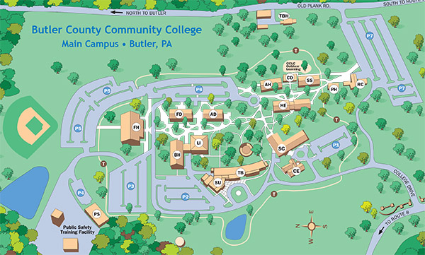

Prerequisites:
- Water rescue training - PFBC Water Rescue and Emergency Response or equivalent (Rescue 3 or other nationally recognized program)
- Advanced Line Systems Rescue or equivalent
- CPR and first aid training
- Teaching experience in EMS, rescue, fire, or similar discipline

Instructor Level Swim Test Standard:
- 200 yards unaided swim – (should demonstrate all four strokes – American Crawl, Breast, Side and
Back Stroke) – 12 minutes
- 100 yards full clothed (long pants and T- shirt) and PFD and helmet – 8 minutes
- Tread water – 10 minutes
- Note: swimming proficiency will be evaluated at the pool session. If unable to pass swim test,
student WILL NOT be permitted to participate in training. Please train and condition prior to the course!!!

Lodging and meals are the responsibility of the student. *Note – when making reservations indicate taking a course at BC3, some hotels may off reduced rates using BC3 for training.

Hampton Inn | 610 Butler Crossing, Butler, PA 16001 | (724) 431-2400
Comfort Inn & Suites | 1 Comfort Lane, Butler, PA, 16001 | (724) 287-7177
SpringHill Suites by Marriott | 125 East Jefferson Street, Butler, PA 16001 | (724) 256-9844
Holiday Inn Express & Suites | 203 North Duffy Rd,  Butler, PA 16001 | (724) 841-0103

HEALTH AND SAFETY Plan – Information will be provided at training. Plan will follow universal
health mandates and guidelines at the time of training.

Hazards of Training:
Students must be prepared to engage in strenuous activities in extreme weather and water conditions. Students must be able to swim. If a student has a known medical condition that could foreseeably jeopardize his/her safety during participation or be aggravated by participation, the student should not participate.

WATER HAZARDS - cold, deep, and swift - water obstructions (i.e. rocks, strainers, free floating debris, etc.) - other water users – please be courteous.

ENVIRONMENTAL HAZARDS - Uneven walking surface, loose debris, slippery rocks, steep slopes, poisonous plants, animals, insects, traffic.

WEATHER HAZARDS - Temperature – hot (hyperthermia) or cold (hypothermia) - storms – lightening (all training will stop until storm has passed). Students will be directed to shelter. Rain, snow or hail may or may not stop training exercise. Weather emergencies will be handled at the discretion of the instructor trainers. Sun exposure (risk of sunburn).

Student Equipment Requirements:
- Customized U. S. Coast Guard approved PFD Type III or V with knife, 2 locking carabineers, and whistle
- Water rescue helmet – must provide front, side, and back of head protection
- Appropriate thermal protection for weather and environmental conditions:
  - Mandatory - Dry suit (Note: cold water exposure, immersion, survival and ice rescue suits are prohibited for moving water)
  - Thermal layering under dry suit - inner wicking material (i.e. polypropylene) - Middle insulation material (i.e. polyester)
- Hand protection for working with rope - neoprene gloves
- Feet protection – river sneakers or neoprene water rescue boots with synthetic or wool blend socks
- Straps for glasses
- Pool session – swimsuit, pants, and T-shirt
- Fluids (water or sports drink) - Food (high-energy snacks)
- Sunscreen – SPF 15 minimum recommended
- Personal items (first aid needs (i.e., inhalers, EpiPen, hygiene items, etc.)
- Towel - Gear bag and large garbage bag to hold wet items

If you have any questions regarding the training, please contact me at 724.287.8711 ext. 8238 or by email chris.calhoun@bc3.edu (include in the subject line of the email water rescue training – I will not open email from unknown senders because of email virus concerns).



NON-CREDIT REGISTRATION FORM
(PLEASE PRINT)

LAST NAME FIRST NAME MI

STREET ADDRESS CITY

STATE ZIP CODE COUNTY OF RESIDENCE

DATE OF BIRTH SEX M/F

( ) ( )
HOME PHONE WORK PHONE

E-MAIL ADDRESS (RECEIVE SCHEDULE UPDATES/EVENT NEWS)

SIGNATURE DATE
IS THIS YOUR FIRST CLASS AT BCCC? YES NO

ARE YOU A PERMANENT* RESIDENT OF PA? YES NO
(*LIVED IN PA FOR THE LAST 12 MONTHS)

PLEASE ENROLL ME IN THE FOLLOWING NONCREDIT COURSE/WORKSHOP/SEMINAR
 | COURSE # | COURSE TITLE
 | Instate:  160006 / 51627 | PA RESIDENT: Water Rescue and Emergency Response Inst.  June 2-4, 2026
 | Out-of-State  160006 / 51628 | OUT-OF–STATE: Water Rescue and Emergency Response Inst.  June 2-4, 2026

_______Attached is my check payable to BC3 _____Out-of-State $550 (check made payable to BC3)
_______PA Resident $450.00

Charge to my: ______VISA _____MasterCard _______Discover Card _______American Express
Account Number__________________________________________________________________
Expiration Date___________________________________________________________________
Signature__________________________________________________________________________
Send all pre-requisite information and payments to:
Butler County Community College
Attn: Maria Chvala
PO Box 1203
Butler, PA 16003-1203
Phone: 724.287.8711 ext. 8355 Fax: 724.284.8548
Email: maria.chvala@bc3.edu

03/05 BC3 IS AN EOE/AA INSTITUTION

