Improving Stream Habitat Strategic Wood Additions

Introduction
Many of the streams in Pennsylvania lack the large woody material (LWM) component normally found within mature, forested landscapes due to previous timber harvesting practices. This woody material can be a beneficial habitat component for the aquatic community, including brook trout. In fact, woody material has been correlated with brook trout abundance (Flebbe and Dolloff 1995, Neumann and Wildman 2002). Large woody material can increase habitat diversity in a homogenous stream reach by creating scour and plunge pools, providing escape cover for trout, and providing substrate and food for aquatic invertebrates on which trout feed. Large woody material will naturally fall into streams given time for the riparian buffer trees to mature, die or blow-over, and eventually fall into the stream. Until then, large woody material can be added to streams where habitat diversity is lacking by directionally felling trees into the stream channel. This document provides an option for improving stream habitat that emulates natural disturbance. The purpose of this practice is not to reach baseline levels of woody material found in streams within old growth forests, but rather to give the stream a head start by adding key pieces of woody material that will then collect other material.

Woody material addictions should only be made where pools are lacking, and habitat diversity is low. A Pennsylvania Fish and Boat Commission (PFBC) habitat assessment (Lutz 2007) should be done to determine if adding woody material will benefit the stream. Streams that may benefit most from woody material have low assessment scores in: Category 1 (Epifaunal Substrate / Available Cover), and Category 3 (Pool Variability). These streams should also have highly stable banks (Category 8) to avoid excessive erosion issues. Often, rocky substrate may provide ample habitat diversity in high gradient first order streams. Adding woody material won’t harm high gradient streams, but the benefits will not be as great as adding woody material to streams lacking habitat diversity.

Considerations
Adding large woody material to streams must be done with caution. Material should not be added near infrastructure such as roads, stream crossings, or developed areas that are not on state forest land. Woody material, although great for habitat, may be obstacles for anglers resulting in more challenging fishing. Therefore, recreation use should be considered when selecting sites for woody material. Adding woody material may also result in localized and temporary erosion issues as water courses adjust to the new structure. This technique is not suitable for understocked riparian areas. This activity must be conducted after December 31st to prevent disturbing trout reproduction. The PFBC Area Fisheries Manager or Habitat Manager must be consulted when considering any trout stream habitat improvement projects. All instream alterations on state forest land require an Environmental Review, which also serves as a waiver. A DEP General Permit (GP-1) is needed prior to any in- stream habitat work, and the GP-1 requires pre-approval from the PFBC Division of Habitat Management. County Conservation Districts can provide assistance with this process.

Practices
The following practices were adapted from New Hampshire NRCS guidelines for adding woody debris to streams and the Oregon Guide to Placement of Wood, Boulders, and Gravel for Habitat Restoration:

- Focus on 1st and 2nd order streams (ranging from 5 to 20 ft wide)
- Focus on low gradient streams lacking pools or habitat diversity
  - Higher gradient streams up to 3% slope may also benefit if lacking habitat diversity
- Ensure ample canopy cover exists for stream shading
- Introduce about 4 pieces of LWM per 100 ft. stream length
  - 1000-foot stream reaches should be targeted for management
- Minimum dbh of key pieces is based on bank-full width (BFW) (larger material is better)
  - Streams up to 10’ BFW: Key pieces 10” diameter
  - Streams 10’ to 20’ BFW: Key pieces 16” diameter
  - Streams 20’ to 32’ BFW: Key pieces 18” diameter
  - Use larger trees at lower end of the reach to collect material moving downstream
- Minimum length of log should be at least twice the bank-full width
- Cut trees beyond the streamside trees, and direct them into the stream
  - Minimize cutting trees that shade or overhang the stream, unless uprooting is occurring
  - Minimize selecting white pine, yellow birch, or serviceberry due to their wildlife value
  - Each site should complete a wildlife value reference guide for no cutting key tree species
- Cut trees so that at least ¼ of the length is on the bank outside of bank-full width to reduce chances of losing woody material during high water events
  - Much of the mass will be above the stream, reducing chances of being washed away
- Do not add woody material near stream/road crossings
  - At least two meander bends should be located between LWM and infrastructure
- Do not add woody material close to state forest boundaries
  - May impact stream reaches on private land
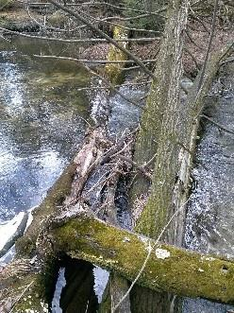
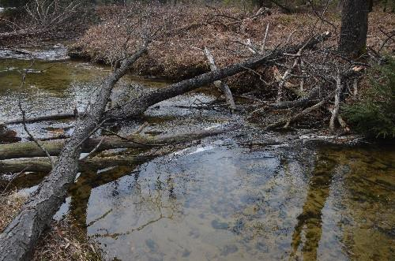
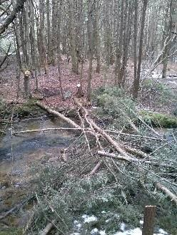
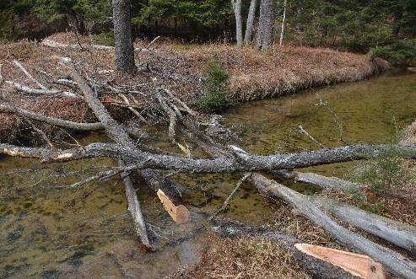

References
Flebbe, P.A. and C.A. Dolloff. 1995. Trout use of woody debris and habitat in Appalachian wilderness streams in North Carolina. North American Journal of Fisheries Management. 15: 579-590.

Lutz, K.J. 2007. Habitat Improvement for Trout Streams. Pennsylvania Fish and Boat Commission. Harrisburg, PA. 40p.

Neumann, R.M. and T.L. Wildman. 2002. Relationships between trout habitat use and woody debris in two southern New England streams. Ecology of Freshwater Fish. 11: 240-250.

NRCS. Guidelines for Wood Additions to First and Second Order Streams. NRCS, Durham, NH. 7p.

Oregon Department of Forestry. 2010. Oregon Guide to Placement of Wood, Boulders, and Gravel for Habitat Restoration. 33p.

LARGE WOOD DEVICES

Plan View

Streambank
Number and configuration of trees may vary depending on site conditions

FLOW

Example 1: Cross Vane (Pool Habitat)
Example 3: Overhead Cover (Bank Stabilization Habitat)

Note: Trees should be large enough
and have enough ballast to prevent movement during high flow periods
Example 2: Directional Flow (Riffle/Run Habitat)
Note: When possible trees should be "pinned" between stumps and or living trees to reduce likelihood of movement
Tree length should be at least
2 times the bankfull width



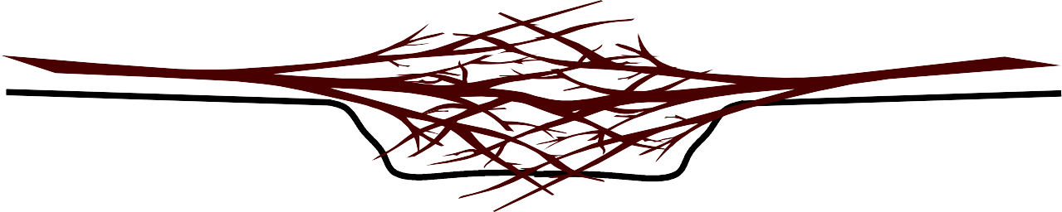
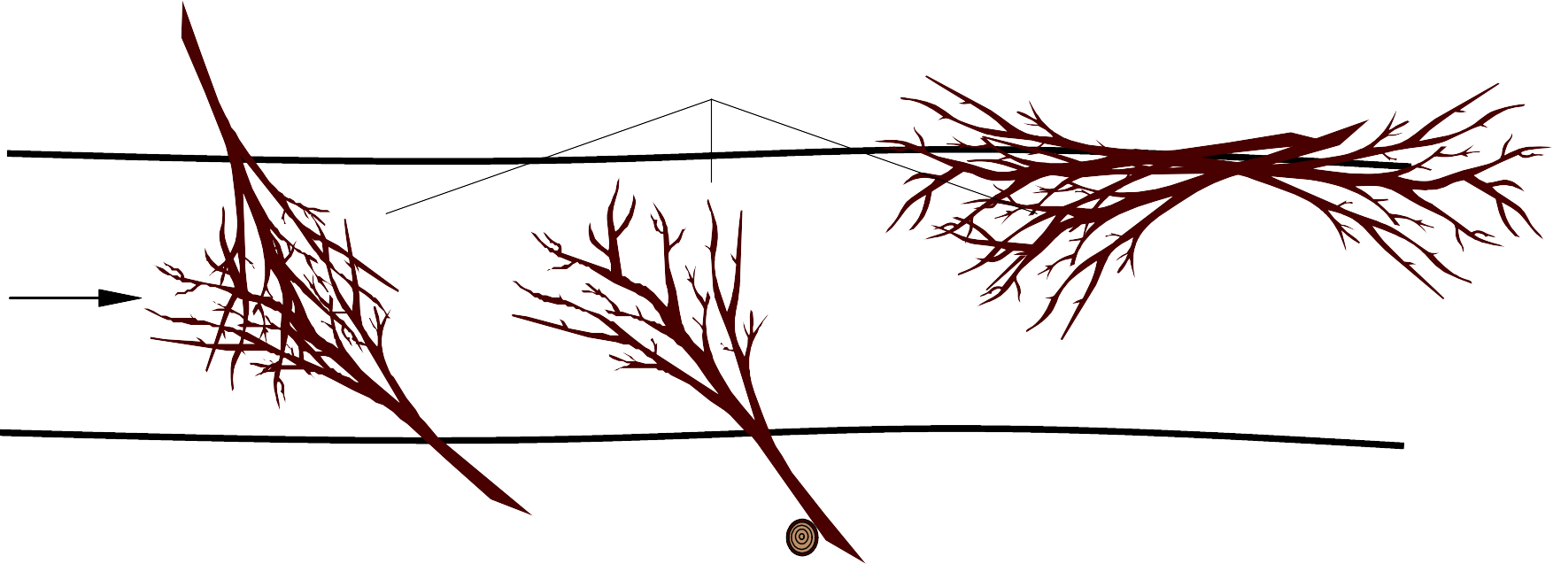
Streambank

Trees = minimum 10" dia.

Normal Water Level

Stream Bottom

Woody material should be in contact with the surface of the water
DHM, PFBC 2022

