Sample reclassification cover sheet

Reclassification Cover Sheet
Student Name:
PASID:
Date:
Grade:
School District:
School:
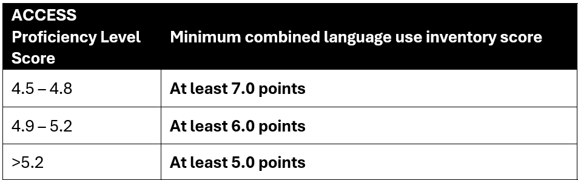
ACCESS Proficiency Level:
Points from language use inventory #1:
Points from language use inventory #2:
Combined points from language use inventories:
Do the combined points meet or exceed the minimum combined language use inventory score for the student’s ACCESS proficiency score?
Based on the student’s ACCESS overall proficiency level score and use of language as observed by his/her teachers, this student is recommended / is not recommended for reclassification as a former EL.
If the student’s score meets the threshold, but the student is not recommended for reclassification, then provide an explanation below.
Notes:

ESL Teacher/Coordinator Signature:
ESL Teacher/Coordinator Printed Name:
The ACCESS score report and rubric scoring sheets should be attached to this form. All information should be provided to the parent(s)/guardians(s) and saved in the student’s permanent academic record either electronically or in paper form.

