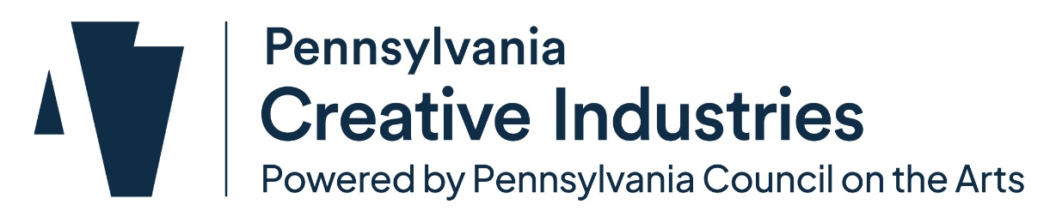
Creative Districts Letter of Intent Form
Submit this form via ESA to no later than June 12, 2026 by 5PM.
Before completing this form, please ensure you have reviewed the full Creative Districts Program Guidelines and understand the expectations for designation. The identified District Coordinating Organization (DCO) must submit this form via ESA. Please refer to the Pre-Application Checklist for links and information.
Date: Click or tap to enter a date.
Organization Legal Name:Click or tap here to enter text.
Organization address: Click or tap here to enter text.
Phone: Click or tap here to enter text.
Website: Click or tap here to enter text.
Primary Contact Name: Click or tap here to enter text.
Title:Click or tap here to enter text.
Email: Click or tap here to enter text.
Phone: Click or tap here to enter text.
Briefly describe the community and the general location of the potential Creative District. (300 word limit. If available, you may include a map as an attachment.) Click or tap here to enter text.
Provide an overview of the selected District Coordinating Organization (DCO). Include the organization’s mission, a brief description of its programs, and the reasons it was chosen to serve as the DCO. (200 word limit.)Click or tap here to enter text.
Provide a list of the organizations partnering to pursue Creative District designation. If the District Coordinating Organization (DCO) is not a community and economic development entity, identify the partner fulfilling that role as outlined in the Eligibility section of the Creative Districts Program Guidelines. Include a brief description of past or ongoing collaborations that demonstrate strong working relationships. (300 word limit.) Click or tap here to enter text.
What planning or implementation activities, if any, has your community undertaken and/or completed so far in exploring or developing a Creative District? (300 word limit.) Click or tap here to enter text.
Why does the community want to pursue Creative District designation and what outcomes do you hope to achieve for residents, businesses, and local talent? (300 word limit.)Click or tap here to enter text.
By submitting this Letter of Intent Form, we acknowledge:
☐ All required Foundational Activities must be documented, completed, and reviewed by Pennsylvania Creative Industries staff and designated panelists in order to be invited to apply for designation.
☐ Local, municipal government leaders are informed about and supportive of pursuing Creative District designation, and that a formal resolution of support must be passed and submitted with the application.
By signing this Letter of Intent, I certify that the information is correct to the best of my knowledge.

